|  |
| --- |
|  |
| **DOCUMENTTYPE**  System Engineering **-** **Team E** |
| **COP** |
| Prepared for: |
| Anders Jacob Truelsen  Anders T.  Christian J.  David |
| Peter H.M.  Michael N.P. |
|  |

|  |  |
| --- | --- |
|  | |
|  | |
| Project: | $System Engineering **– Team E** |
| Revision: | $Revision: 1A$ $Date:25092010$ |
| Document: | $ |
|  | |

Table of Contents

1 Introduction (Michael) 1

2 Vision & Scope (Peter) 1

3 Stakeholder needs 2

3.1 Identify legitimate stakeholders (Anders) 2

3.2 Legitimate stakeholder needs (Anders) 3

3.3 Elicit requirements(Michael) 3

3.3.1 Existing systems 4

3.3.2 Mission analysis 4

3.3.3 User requirements 5

3.4 System solution constraints 5

4 Concept documents (David) 5

4.1 Concept of operation 5

5 Requirements specification, Primary (Michael) 5

5.1 Functional requirements (David) 5

5.2 Non-functional requirements 6

5.3 Performance requirements 6

6 Architectural constraints (Michael) 6

7 Verification strategy/Qualifications provisions 6

7.1 Qualification Methods 6

8 Requirements traceability 7

9 Requirements specification, Sub-supplier (Michael) 8

9.1 Functional requirements 8

9.2 Non-functional requirements 8

9.3 Performance requirements 8

10 Verification strategy/Qualifications provisions 8

10.1 Qualification Methods 8

11 Bibliography 10

# Introduction (Michael)

This case will investigate the initial processes from the INCOSE Systems Engineering Handbook[1]. It has the purpose to educate the attendees in applying the technical processes be using them in a real life case with unreal companies involved. The case work will furthermore train the attendees in the art of systems engineering in general. The case work will also end with a description of the case unique requirements in order to develop the suggested Common Operation Picture (COP).

# Vision & Scope (Peter)

In crisis situations coordination between authorities is very important. A train accident may require involvement from authorities such as traffic police, Medicare, fire fighters and train related authorities.

It is crucial that the commander in charge has the optimum situational awareness, which is also known as the Common Operations Picture (COP).

Systematic provides with its SitaWare solution a complete COP management system for military purposes.

Systematic wishes to extend its solution to the domestic area. The intention is to provide a COP collecting infrastructural, personnel and other important data to the commander in charge, such as a fire chief or similar.

The solution relies on data obtained from public data bases, but accessed using dedicated means of data transmission, as existing public data infrastructure may be absent or unstable.

The system must be portable by means of a container installation.

Power supply and redundancy is outside the scope of this specification.

Key features are:

* Collection, pre-processing and presentation of information about:
  + Weather
  + Hazardous Materials
  + Construction Work
  + Demographic Data
  + Actors within the COP
* Distribute Information to Actors
* Review information history
* Change information focus

The following sections describes the stakeholders involved and their requirements to the solution

Systematic would like a proposal for a future dismounted COP terminal. This terminal will be a subset of the proposed solution. Appendix XX will describe the sub-set of requirements that applies to this solution.

# Stakeholder needs

## Identify legitimate stakeholders (Anders)

In order to identify legitimate stakeholders, an overview of the system and its subsystems working in its environment is necessary. This overview will make it possible to identify the most important stakeholders. A stake holder is defined as someone or something that can directly influence the use and the design of the system. It is important to identify all the human and non-human stakeholders. By looking at figure(), one can see a very simple overview of the systems structure. By understanding this structure, the most obvious stakeholders can be identified, and how these individual stakeholders can affect the system. A stakeholder in this system can be described as one of the many subsystems that are involved with the main system. There are the human actors and the non-human actors. The human actors that use the system are the people in the command center and the people out in the field. Another human actor is the ones who secure the command center, and protect the workers of this center. It could be a security team, or part of the police force that also are used as the police force out in the field.

The non-human actors that are immediately obvious are the subsystems like the main system, the handheld devices, the radio communications systems, the GPS system and etc. Another type of stakeholders that can be identified, are the nonhuman actors, like the main power supply system and the water supply system, for the users and the people in the command center. If the system is to work in a disaster area, this must be taken into consideration. The last stake holder that can have some issues with this system is the radio communication regulative. The system must comply with standard laws about radio frequencies and power outputs.

The human stakeholders can be highlighted as.

* Staff at the command centre
* Fire department
* Police force
* Medical teams
* Observation Teams
* Maintenance crew for the system
* Command centre protection and accessibility

The nonhuman stakeholders can be highlighted as.

* Main system
* Handheld devices
* GPS system
* Radio communication system
* Radio communication regulative
* Power supply system
* Water supply system
* Internet
* Various information websites(DMI)
* Communication sites(situation update blog)

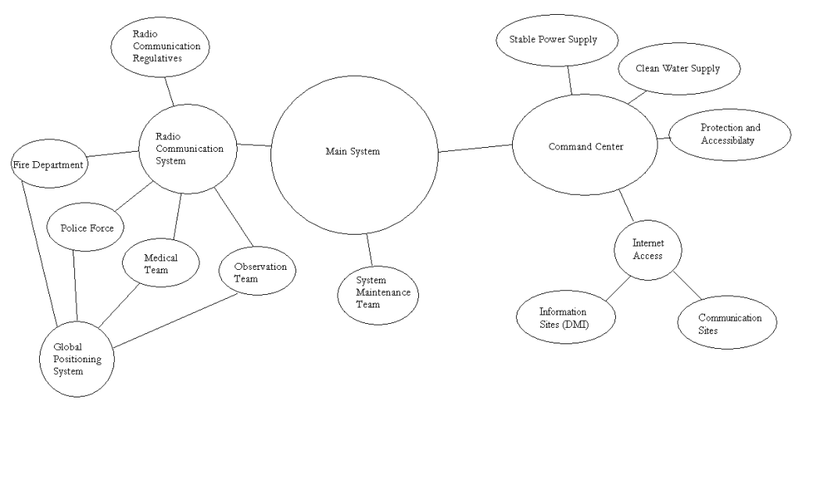

Figure - Stakeholder diagram

## Legitimate stakeholder needs (Anders)

Police – Needs information about traffic, roads and infrastructure

Armed forces – Needs information about non-civil matters

Hospitals – Will be informed about casualties, water and energy supply.

Emergency Management – Energy and Water information

Fire Fighters – Information about water supplies and emergencies

## Elicit requirements(Michael)

In order to elicit the requirements it is important to understand the needs from each of the identified stakeholders. Table 1 shows the stakeholders in the case together with their level in the project and identifies if they have any decision power.

|  |  |  |
| --- | --- | --- |
|  | **Has decision power** | **Has no decision power** |
| **Directly involved stakeholder** | Systematic (Costumer)  The development team | Police, armed forces, hospitals etc. |
| **Not directly involved stakeholder** | The government  Legal parties | Commanders |

Table - Stakeholder matrix

*Many tools and techniques can be used to elicit user requirements, such as marketing and technical questionnaires or surveys, focus groups, prototypes, and beta release of a product. Trade off analysis and simulation tools can also be used to evaluate mission operational alternatives and select the desired mission alternative[1]*.

It is therefore important to gather stakeholder inputs on “needs” and “wants” in order to define the system constraints. The customer might have limitation to the total budget, limitation in technology, and legal requirements. This process is initiated by studying both how it is done without any high tech solution and evaluate the amount off added technology compared with the added benefits of doing so.

### Existing systems

Each and every department has its own chain of command, where information will be managed from the top and down. The information is delivered trough radio and details like location is plotted on an old fashion map. This system is well known and has proven its worth throughout the history, but of cause some major disadvantages can be highlighted.

* Misinterpretation of information since it is verbally translated
* Lack of cross compatibility between existing systems and involved parties
* Information overload in some parts in the chain of command

The development team has recognized that these three issues is to be improved be using new technology to handle emergency situations and establishing the COP.

### Mission analysis

The success of the mission might depend of using just the right amount of added technology. The mission might be corrupted by adding to much technology, which could make it almost impossible to operate. The development team has considered the mission performance versus the amount of added technology.

In order to handle an emergency situation without automatic and intelligent systems to filter information and share important knowledge it can be quite a challenge to make an emergency operation run smoothly. The commanders face this exact challenge today.

It is of highest importance that the commanders feel that they are in charge, when they use the system and that they control the important stream of information. The system might suggest and point out critical elements, but it is the development team believes that an emergency situation is dynamic and cannot be controlled by a computer. The COP should provide the right amount of information, and ensure that everything is updated. The COP might be able to filter out some of the less critical information, by correlating some emergency facts with information available. This will help the commander focus on what is important, without being under informed.

The system might be even a bigger help for the people in the field, because they might experience “a hectic life” and they do not need to feel in command, but need to be commanded. The system will therefore help them filter the information based on their location. The sum of this analysis is three subsystems within the system of interest, which must be implemented be means of added technology.

* Redundant communication interface to ensure information exchange between involved parties
* Location tracking system
* Critical information back-up system

### User requirements

The development team has collected user requirements by means of questionnaires, interviews and by discussing the customer produced document in which they present their view on the problem. These investigations have lead to the build scenarios, which will help define the project requirements.

## System solution constraints

See *Statement of Work* [2] for description.

# Concept documents (David)

## Concept of operation

# Requirements specification, Primary

This chapter characterizes the requirements according to satisfy the system functionality and performance.

The purpose of this chapter is to specify the requirements and qualifications provisions to the system in order to obtain product acceptance.

This Requirements specification is used to gain overview of the functionality and demands there are to the COP.

All the requirements have the unique prefix identifier SCOP with a four-digit suffix.

## Functional requirements (David)

1. Rfgfd
2. Gh
3. Fgd
4. Fdg

## Non-functional requirements

## Performance requirements

# Architectural constraints (Michael)

There is no overall system architecture, since no particular hardware or programming language can be defined (TBD). Because the main problem is to implement a cross compatible COP system, it must of course be able to handle the specific data communication standards.

The handheld device should contain some sort of processor and memory storage in order to process the software that will present the common operation picture.

The flexibility of the system relates to the number handheld devices that the system supports.

As the system is designed on a specific hardware platform, it should be possible to reuse the system on another platform.

Therefore, it is a design goal to use none hardware specific elements.

# Verification strategy/Qualifications provisions

This chapter will describe how project unique requirements shall be verified.

## Qualification Methods

The qualification methods used to verify that the requirements of the COP system are used and include the following definitions:

Demonstration: The operation of the system, or a part of the system, that relies on observable functional operation not requiring the use of instrumentation, special test equipment, or subsequent analysis.

Test: The operation of the system, or a part of the system, using instrumentation or other special test equipment to collect data for later analysis.

Analysis: A review of test data (from the test) and theoretical analysis required to verify the requirements. The processing of accumulated data obtained from other qualification methods. Examples are reduction, interpolation, or extrapolation of test results.

Inspection: Visual examination of system components, documentation, etc.

|  |  |
| --- | --- |
| **Requirement** | **Qualification Method** |
| **SCOP-0001** | Analysis |
| **SCOP-0002** | Test |
| **SCOP-0003** | Test |
| **SCOP-0004** | Demonstration |
| **SCOP-0005** | Demonstration |
| **SCOP-0006** | Demonstration |
| **SCOP-0007** | Demonstration |
| **SCOP-0008** |  |
| **SCOP-0009** |  |
| **SCOP-0010** |  |
| **SCOP-0011** |  |
| **SCOP-0012** |  |
| **SCOP-0013** |  |
| **SCOP-0014** |  |
| **SCOP-0015** |  |

Table - Qualification matrix

# Requirements traceability

See *Requirements Traceability Matrix* [3] for description.

# Requirements specification, Sub-supplier (Michael)

This chapter characterizes the requirements according to satisfy the system functionality and performance.

The purpose of this chapter is to specify the requirements and qualifications provisions to the system in order to obtain product acceptance.

All the requirements have the unique prefix identifier TPOD with a four-digit suffix.

## Functional requirements

1. The handheld device should be able to interface with every one of the commercial existing systems within the involved domains also including GSM.

## Non-functional requirements

1. The handheld device must cost less than 25000 Danish kroner.
2. The handheld unit must not weigh more than 1000g
3. The screen on handheld device shall be between 10”-12”.
4. The handheld ...

## Performance requirements

1. …

# Verification strategy/Qualifications provisions

This chapter will describe how project unique requirements shall be verified.

## Qualification Methods

The qualification methods used to verify that the requirements of the COP system are used and include the following definitions:

Demonstration: The operation of the system, or a part of the system, that relies on observable functional operation not requiring the use of instrumentation, special test equipment, or subsequent analysis.

Test: The operation of the system, or a part of the system, using instrumentation or other special test equipment to collect data for later analysis.

Analysis: A review of test data (from the test) and theoretical analysis required to verify the requirements. The processing of accumulated data obtained from other qualification methods. Examples are reduction, interpolation, or extrapolation of test results.

Inspection: Visual examination of system components, documentation, etc.

|  |  |
| --- | --- |
| **Requirement** | **Qualification Method** |
| **TPOD-0001** |  |

Table - Qualification matrix

# Bibliography

1. **International Council on Systems Engineering**.*INCOSE Systems Engineering Handbook v. 3.2a*.INCOSE, 2010.
2. **SoW**. Company E, 2010.
3. **Requirements Traceability Matrix**, Company E, 2010